5.39: a)
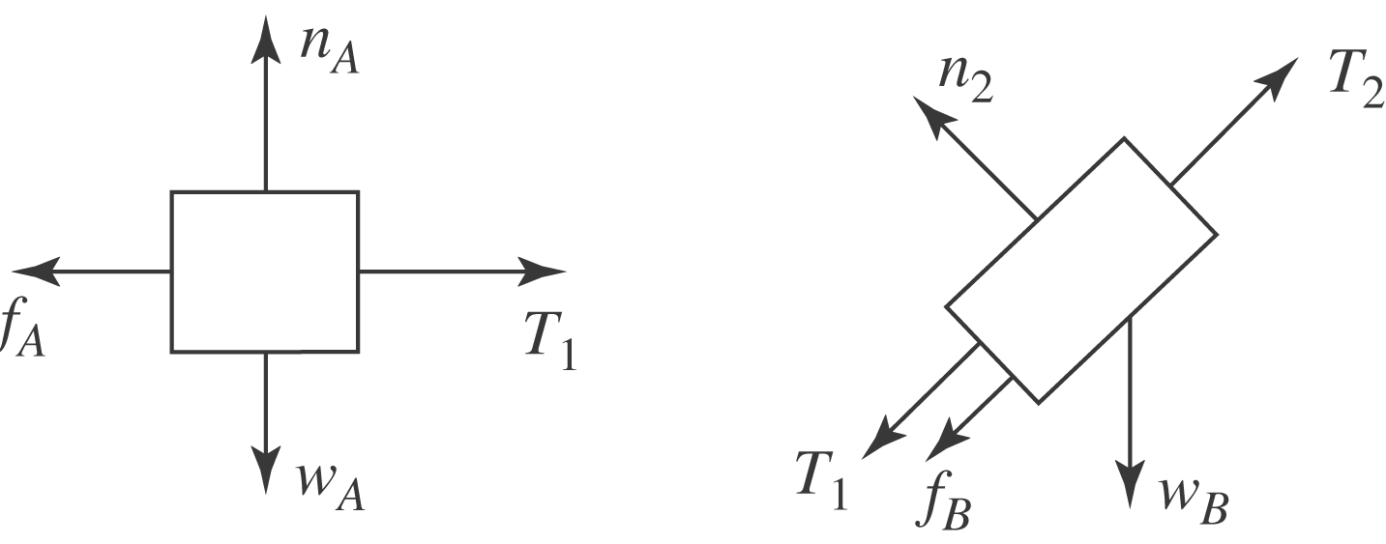

b) The blocks move with constant speed, so there is no net force on block A; the tension in the rope connecting A and B must be equal to the frictional force on block A, 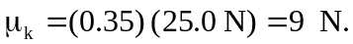 c) The weight of block C will be the tension in the rope connecting B and C; this is found by considering the forces on block B. The components of force along the ramp are the tension in the first rope (9 N, from part (a)), the component of the weight along the ramp, the friction on block B and the tension in the second rope. Thus, the weight of block C is
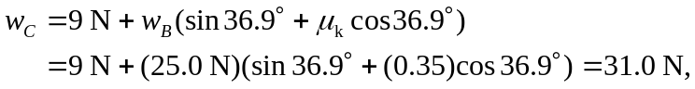
or 31 N to two figures. The intermediate calculation of the first tension may be avoided to obtain the answer in terms of the common weight w of blocks A and B,
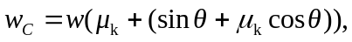
giving the same result.

(d) Applying Newton’s Second Law to the remaining masses (B and C) gives:

